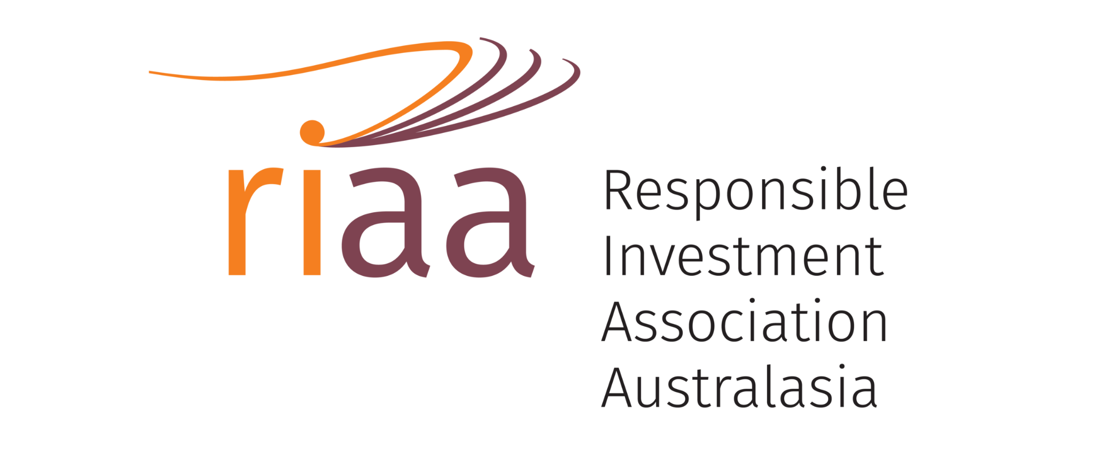
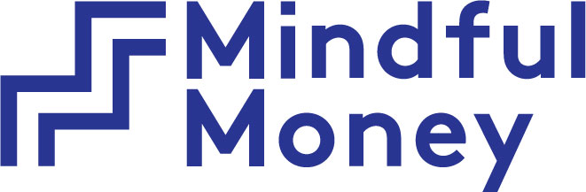

Media Release
Embargoed for release until 28 April 2022
Key Points:
- 73% of New Zealanders want their funds to be invested ethically
- 62% of New Zealanders say it is important to them that their investment makes a positive difference in the world
- 53% of New Zealanders would save more if they knew their savings would make a positive difference

Three-quarters of New Zealanders expect their KiwiSaver and investment funds to be invested ethically, with the majority considering moving funds if their values and interests do not align. This is one of the key findings of the new consumer survey by Mindful Money and the Responsible Investment Association Australasia (RIAA).

From Values to Riches 2022: Charting consumer demand for responsible investing in Aotearoa New Zealand, undertaken by Dynata, highlights that investors are not only looking for their fund providers to do well – they are looking for funds that also do good. 62% of New Zealanders report it is important to them that their investment makes a positive difference in the world. Expectations are higher among women (80%) than men (63%) and are highest among young people aged 18-24 (78%) who believe responsible investments will outperform traditional funds over the long term.

Barry Coates, CEO of Mindful Money commented: “The survey results are a clear signal to the finance sector that retail investors are looking for KiwiSaver and investment funds that align with their values. This means avoiding investing in companies that do harm and including investments in creating positive impacts. As the market continues its rapid growth, there will be opportunities for the fund providers that can respond to these consumer demands.”

Simon O’Connor, CEO at RIAA said: “This survey shows that half the population are apprehensive that fund providers are greenwashing and making misleading claims, and are demanding that their providers can back up their claims. Consumers have awoken to the opportunity to invest in line with their values but are also much more attuned to cut through the spin to find products that deliver on the most important issues for them.”

“More than half of the population (54%) would be more willing to invest ethically and responsibly if financial products were certified or labelled as responsible or ethical by an independent third party. With the barrage of new ethical investment products in the market, consumers are increasingly questioning sustainability claims made by investment managers. They’re looking to trusted third parties like RIAA’s Responsible Investment Certification Program to do the heavy lifting, to make sure they are delivering on their claims.”

The report also shows that a large proportion of the public wants to avoid a range of sectors and company practices, led by issues such as human rights, labour rights and the environment. The overwhelming majority (90%) of Kiwis do not want their money invested in companies or governments involved in human rights abuses.

Barry Coates said: “The strength of concern over human rights violations was shown in the recent public outrage after revelations that more than a hundred KiwiSaver funds had investments in Russian government bonds or in companies linked to the Russian Government.”

Barry Coates commented: “The investment sector should look closely at this survey if they want to be responsive to the demands of retail investors. While most of the investment sector excludes tobacco products and controversial weapons, they ignore concerns about other issues that consumers identify as important. For example, 74% of Kiwis want to avoid investing in animal products, but there are no diversified funds currently offering these funds, and 84% of people want to avoid companies that test their products on animals, but only two providers offer fund options.”

Simon O’Connor said: “Awareness and understanding of responsible investment is on the rise and reflects the reality that money is moving across into funds of investment managers that are doing responsible investment well.”

The outlook is bright for ethical and responsible investing in New Zealand, despite concerns about greenwashing. In addition to those who already have an ethical fund, two-thirds (65%) of others intend to invest ethically in the future, most of them in the next year.
New Zealanders want the finance sector to take action on climate change, with half of those surveyed saying it is important that their fund or investment scheme provider sets targets to reduce emissions. Other key areas of impact for investing cited include healthy rivers and oceans, healthcare and public health, sustainable water management, and renewable energy and energy efficiency. The survey also found that if Kiwis know that their savings make a positive difference, 53% would save more.

Simon O’Connor said: "Investors are refining the ways they can deliver positive change with their investments. Beyond divestment, more investors are using their ownership of companies to drive change, from voting at AGMs, to engagement, filing resolutions, and collaborating for public policy changes. Leading investors are holding companies to account across a range of issues, to ensure they have ambitious plans for a net zero transition, to improve their human rights performance, and to strengthen gender diversity. The results of this research are a wake-up call to investment managers to better communicate the results of this engagement to consumers."

Barry Coates said: "The survey results show that there is a clear appetite for investments that have real-world impact. The challenge is for investment providers to show that they are avoiding the companies that the public don’t want to invest in, and instead build positive impact investments into their offerings. Investors should have the opportunity to feel good about their investments, do good in the world and earn good returns.”

Contact:
Barry Coates, CEO of Mindful Money
barry@mindfulmoney.nz
021 365 165

Simon O’Connor, CEO of Responsible Investment Association Australasia (RIAA) is available for interview. Please contact:
Katie Braid
katie@responsibleinvestment.org
+61 405 177 346

